## **COSC 30603**

**Homework 3**

Due: Sep 14

Requirement: Your answers must be typed. ER diagrams must be following the notations from the book. Please don’t convert to PDF. Just turn in this word doc.

1. Consider the following data requirements for a banking application.

A bank account has an account number, an opening date and a balance. There are two types of accounts: checking and saving. An account must be at least either saving or checking, while some accounts can be both saving and checking. A saving account has an interest rate while a checking account has a minimum deposit amount. An account owner has an owner id and a start date. An owner may own several accounts, while an account can have several owners. An owner always owns at least one account, while not every account has an owner.A check has a check number, which is unique only in the same checking account. A check also has a date and an amount. A check must belong to one and only one checking account while a check account may have many checks.

There are two categories of owners: person and company. A person has a first name, a last name, and an SSN. A company has a name, a tax id and an address. Every company is an owner, while not every person is an owner. A bank employee has an SSN, a name (first and last) and a start date. Some bank employees are account owners. Each employee-owner has a bonus interest rate.

Draw an EER diagram based on the requirements. (50 pts):

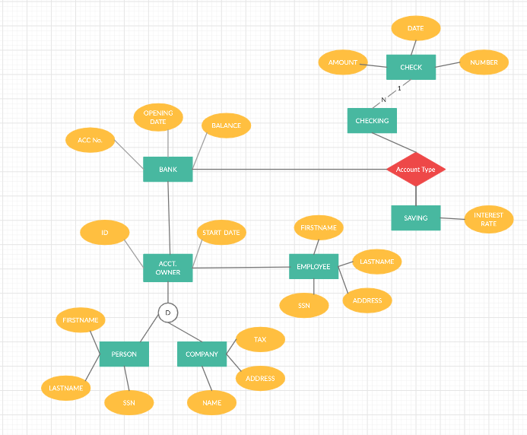

1. Consider the following EER diagram. Map it into a relational database schema. Hint: Do not forget to add UNIQUE and NOT NULL in the schema where they needed. (50 pts):

* Author(SSN, name, first, last), PK: SSN UNIQUE, NOT NULL, FK: Cid references CUSTOMER.
* Book(ISBN, title, page_number, SSN, pid), PK: ISBN UNIQUE, NOT NULL.
* Handcover(id, ISBN).
* Audiobook(id, ISBN).
* Paperback(id, ISBN).
* Movie(title, director, year, pid), FK: pid NOT NULL references PRODUCT.
* Product(pid, price), PK: pid UNIQUE, NOT NULL.
* Customer(cid, sign_date, pid), PK: cid UNIQUE, NOT NULL.
* Author_Customer(author_id, discount, cid, SSN), PK: Cid UNIQUE, NOT NULL, FK: Cid references CUSTOMER.
* Buy(Cid, Pid), PK: Cid, Pid UNIQUE, NOT NULL.
* WRITE(ISBN, SSN), PK: ISBN, SSN UNIQUE, NOT NULL.









